**Experiment # 05**

**OBJECTIVE:**

To become familiar with bubble sort technique in arrays

**Theory:**

**Bubble Sort:**

Bubble sort is also known as Exchange Sort. It repeatedly visits the array and compares two items at a time .it swaps these two items if they are in the wrong order. It continues to visit the array until no swaps are needed that means the array is sorted.

**Algorithm for Bubble Sort**

* Compare adjacent elements .if the first is greater than the second, swap them.
* Repeat this for each pair of adjacent elements, starting first two and ending with the last two. At this point the last element should be the greatest.
* Repeat the step for all elements except the last one.
* Keep repeating for one fewer element each time until there are no pairs to compare.

**Lab Tasks:**

**QNo:01 Develop a code in C++ that execute bubble sort algorithm.**

**QNo:02 Compile and Execute the Given Code and display its output.**

#include<iostream.h>

#include<conio.h>

Void main()

{

Int arr[5]={ 11,44,22,66,33};

Int I,j,temp;

Cout<<”The Orignal values in Array\n”;

for(i=0;i<5;i++)

cout<<arr[i]<<” “;

for(i=0;i<5;i++)

for(j=0;j<4;j++)

if(arr[j]>arr[j+1])p

{

temp=arr[j];

arr[j]=arr[j+1];

arr[j+1]=temp;

}

Cout<<”\nThe Sorted Array:/n”;

for(i=0;i<5;i++)

cout<<arr[i]<<” “;

getch();

}

**QUESTION NUMBER : 01:**

**Develop a code in C++ that execute bubble sort algorithm..**

**PROGRAM:**

#include <iostream>

using namespace std;

int main ()

{

int arr[5],i,j,temp;

for(i=0; i<5; i++)

{

cout <<"Enter the value of the array=";

cin>>arr[i];

}

cout <<"\nThe original value in the array are \n";

for(i=0; i<5; i++)

{

cout<<arr[i]<<" ";

}

for(i=0; i<5; i++)

for(j=0; j<4; j++)

if(arr[j]>arr[i+1])

{

temp=arr[j];

arr[j]=arr[i+1];

arr[i+1]=temp;

}

cout <<"\nthe sort array=";

for(i=0; i<5; i++)

{

cout <<arr[i]<<" ";

}

return 0;

}

**OUTPUT:**

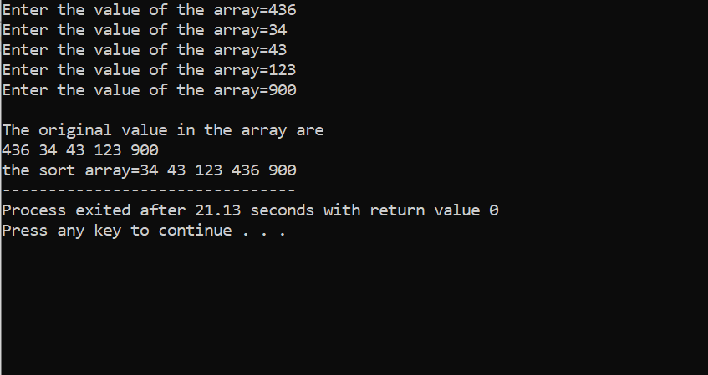

**QUESTION NUMBER : 02:**

**Compile and Execute the Given Code and display its output.**

**PROGRAM:**

#include <iostream>

#include<conio.h>

using namespace std;

int main()

{

int arr[5]={ 11,44,22,66,33};

int i,j,temp;

cout<<" The Orignal values in Array\n";

for(i=0;i<5;i++)

cout<<arr[i]<<" ";

for(i=0;i<5;i++)

for(j=0;j<4;j++)

if(arr[j]>arr[j+1])

{

temp=arr[j];

arr[j]=arr[j+1];

arr[j+1]=temp;

}

cout<<"\n The Sorted Array "<<endl;

for(i=0;i<5;i++)

cout<<arr[i]<<" ";

getch();

}

**OUTPUT:**

